In-depth Research Report: Cross-Site Request Forgery (CSRF)

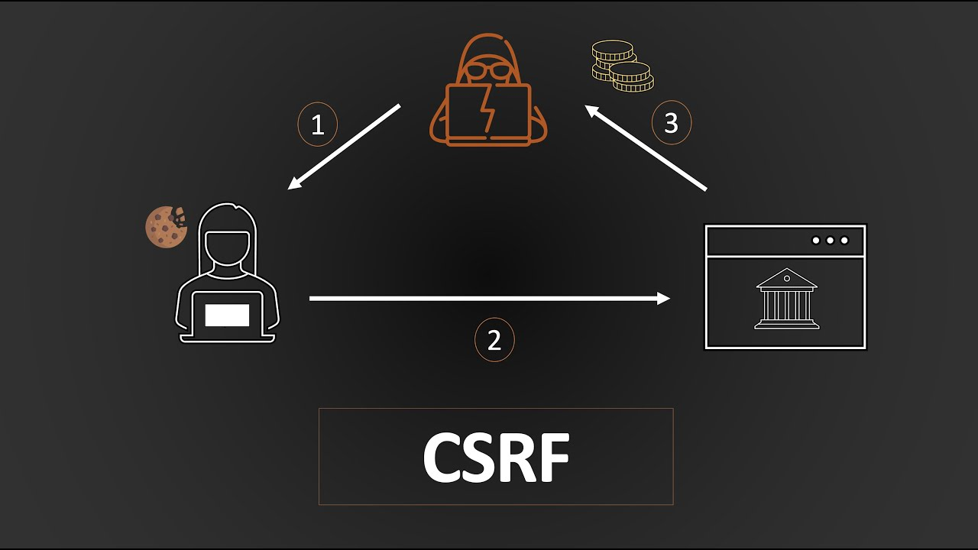

1. What is CSRF?
Cross-Site Request Forgery (CSRF), also known as session riding or XSRF, is a type of security vulnerability found in web applications. It occurs when an attacker tricks a user into unintentionally executing malicious actions in an application where the user is authenticated. The web server cannot distinguish between legitimate actions initiated by the user and those initiated by an attacker, leading to unauthorized actions being performed on behalf of the user.
In a typical scenario, the attacker forces the user’s browser to send a request to the target web server using the victim’s authentication tokens (e.g., cookies, session IDs, or credentials). Since the web server has no way of distinguishing between requests originating from the user or from an attacker, the malicious request is executed, leading to unauthorized actions.
Key Features of CSRF:
- The attacker does not need to compromise the user’s account or gain direct access to the user’s credentials.
- The attack takes advantage of the trust that a website has in the user’s browser and authenticated session.
- CSRF exploits browser behavior, as browsers automatically include credentials (like cookies) in requests to a trusted domain.

2. How does a CSRF attack work?
A CSRF attack is crafted by the attacker with the intent to perform actions on behalf of the victim. The attack consists of the following steps:
Step 1: Victim logs in: The user logs into a web application that requires authentication. Once logged in, the server issues a session identifier (cookie) to the user's browser, which is used for subsequent requests to the server.
Step 2: Attacker prepares malicious request: The attacker crafts a malicious request, typically in the form of a GET or POST request, designed to perform an action on behalf of the victim (e.g., transferring money, changing email addresses). This request includes the action the attacker wants to perform and exploits the fact that the user’s browser will automatically include authentication tokens in the request.
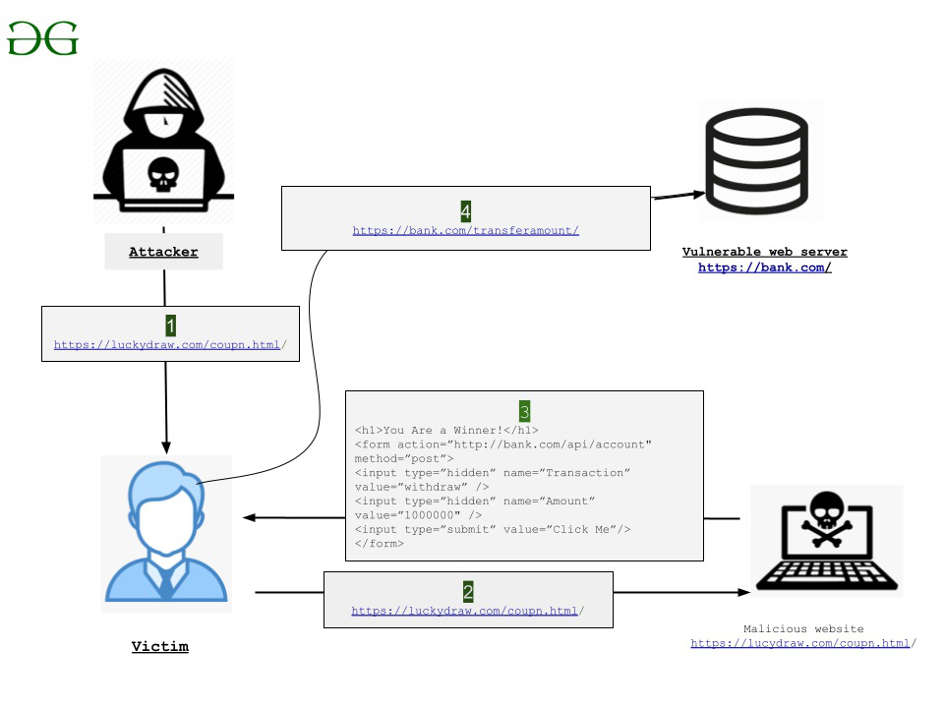
For example, a malicious request might look like:
<img src="https://bank.com/transfer?amount=1000&to_account=attacker_account" />

In this case, an image tag in the attacker's website forces the user’s browser to send a GET request to the bank to transfer money.
Step 3: Attacker sends malicious link: The attacker embeds the malicious request in a link, image, or form and sends it to the victim through email, instant messaging, or a compromised website.
Step 4: Victim performs action unknowingly: The victim, unaware of the malicious request, clicks the link or visits a webpage with the malicious request embedded. The browser automatically includes the authentication tokens in the request (such as cookies or session headers), making the request appear as if it came directly from the authenticated user.
Step 5: Server processes the request: The web server, seeing a legitimate request from an authenticated user, processes the request and executes the attacker’s desired action (such as transferring funds or changing account details).

Example CSRF Attack Scenario:
Imagine an online banking platform with a feature that allows users to transfer funds between accounts. If the form for transferring funds does not have adequate protection against CSRF, an attacker could craft a malicious form to trigger a fund transfer:
<form action="https://bank.com/transfer" method="POST">
<input type="hidden" name="amount" value="1000">
<input type="hidden" name="to_account" value="attacker_account">
<input type="submit" value="Transfer">
</form>
If the user is logged into the banking site, and they are tricked into submitting this form (e.g., by clicking a phishing link or visiting a malicious webpage), the bank would process the request, transferring money to the attacker’s account.

3. How do you test for CSRF vulnerability?
To test for CSRF, the primary focus is on determining whether a web application has appropriate defenses to prevent cross-origin requests from being processed. Below are the key methods and steps used to test for CSRF vulnerabilities:

A. Check for CSRF Token Presence:
CSRF Token: A CSRF token is a unique, unpredictable, and user-specific value included in HTTP requests. The server validates the token before processing any sensitive operations.
Testing Procedure:
  - Step 1: Inspect the HTML form or API request to verify whether a CSRF token is included.
  - Step 2: Submit the form without the CSRF token or with a modified token and observe the server's response. If the request is accepted, the application may be vulnerable to CSRF.
Example request without a CSRF token:
POST /transfer HTTP/1.1
Host: bank.com
Cookie: session=valid-session-cookie
amount=1000&to_account=12345
If the server processes this request without checking for a CSRF token, the application is likely vulnerable.

B. Examine Request Headers and Cookies:
Origin and Referer Headers: Many web servers use the Origin or Referer headers to determine the source of a request. If the Origin header is missing or the Referer header shows a different domain, the server should reject the request.
Testing Procedure:
  - Intercept a legitimate request using a tool like Burp Suite.
  - Modify the Origin and Referer headers to simulate a request coming from a third-party website.
  - If the server processes the request despite the headers indicating an untrusted origin, it is likely vulnerable.

Tools for CSRF Testing:
Several tools can assist with identifying CSRF vulnerabilities:
Burp Suite: One of the most commonly used tools for security testing, it has extensions like the CSRF Scanner that automate the detection of missing CSRF protections.
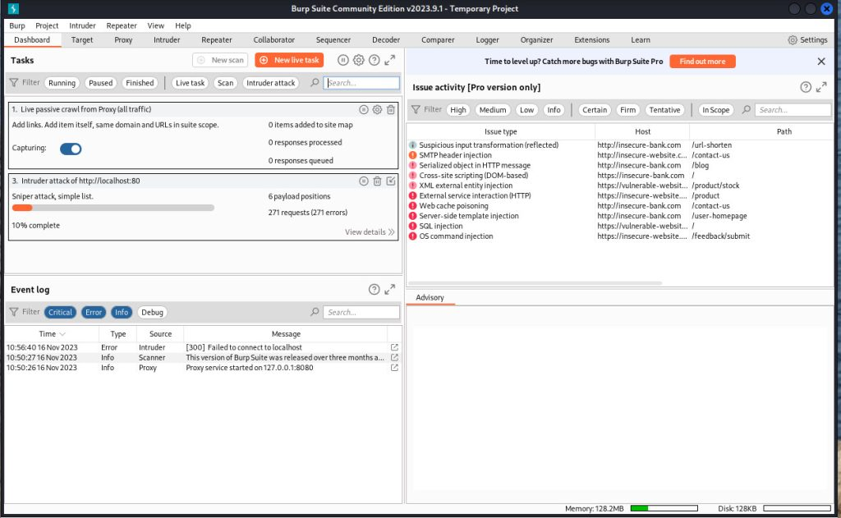
OWASP ZAP: Another powerful tool that can detect potential CSRF vulnerabilities and offers automated scanning for applications without CSRF tokens.
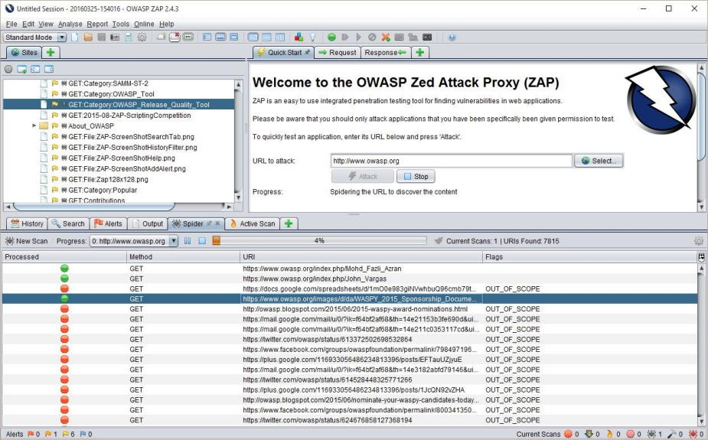

Postman: This tool allows manual API testing. Remove the CSRF token from requests to see if the server validates the token. If the server processes the request without the token, the application is vulnerable.
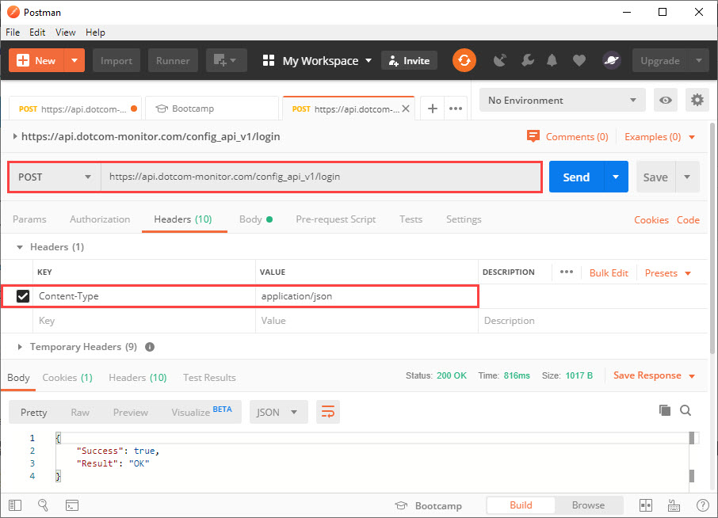

D. Manual Testing for URL-Based CSRF:
Some web applications may be vulnerable to URL-based CSRF attacks (GET requests). Test these by:
- Step 1: Inspect URLs that perform sensitive actions (e.g., account changes, fund transfers).
- Step 2: Embed the URL in an HTML <img> or <a> tag and trick the victim into clicking it.
- Step 3: Check if the action is performed without CSRF token validation.

4. Impact and Mitigation Measures

Impact of a CSRF Attack:
The impact of a successful CSRF attack varies depending on the nature of the application and the actions available to authenticated users.
Common consequences include:
Financial Loss: Attackers can initiate financial transactions on behalf of the user (e.g., transferring money, purchasing items).
Data Compromise: Sensitive user data (such as email addresses, passwords, and personal information) can be changed or leaked.
Privilege Escalation: In some cases, CSRF vulnerabilities in administrative accounts can lead to attackers gaining control over an entire application or system.
Reputation Damage: An application suffering from a CSRF attack may lose users' trust and damage its reputation, particularly if sensitive information or money is stolen.

Mitigation Measures:
There are several effective strategies for mitigating CSRF vulnerabilities. Key methods include:
Use of CSRF Tokens:
Best Practice: Every form or state-changing operation should include a CSRF token. The token should be unique per user session and included in each request (e.g., as a hidden form field or request parameter). The server validates the token to ensure that it matches the expected value.
Implementation:
  - Ensure tokens are generated on the server-side and associated with each user session.
  - Include CSRF tokens in forms and API requests.
  - Reject any request without a valid CSRF token.
• SameSite Cookies:
The SameSite attribute on cookies can prevent browsers from sending cookies in cross-origin requests. This can effectively prevent CSRF attacks by ensuring that authentication cookies are not sent with requests originating from third-party websites.
Best Practice: Set cookies with the SameSite=Lax or SameSite=Strict attribute.
Example:
Set-Cookie: session=abc123; SameSite=Lax
• Checking Origin and Referer Headers:
- •
Many modern browsers include the Origin or Referer header in requests. The server can validate these headers to verify that the request originated from a trusted domain.
Implementation: Ensure the server checks the Origin header for sensitive requests and rejects requests from untrusted origins.
• Double-Submit Cookies:
A technique that involves sending a CSRF token both as a cookie and as a request parameter. The server checks that both values match to ensure that the request is legitimate.
Implementation: Include the CSRF token in both the request body and as a cookie, and verify that they match on the server-side.
• Use CAPTCHAs:
CAPTCHAs can be used to protect sensitive operations by ensuring

References
- OWASP Foundation. "Cross-Site Request Forgery (CSRF)." OWASP, 2023. https://owasp.org/www-community/attacks/csrf.
- Mozilla Developer Network (MDN). "SameSite Cookies." MDN Web Docs, 2023. https://developer.mozilla.org/en-US/docs/Web/HTTP/Headers/Set-Cookie/SameSite.
- The Open Web Application Security Project (OWASP). "Testing for CSRF (OWASP-CM-001)." OWASP Testing Guide v4, 2023. https://owasp.org/www-project-web-security-testing-guide/v41/4-Web_Application_Security_Testing/07-Testing_for_Security_Controls/05-Testing_for_CSRF.

